Study of Human Behavior Shaped in Building Fire Evacuation
XIAO Guoqing¹ ², LIAO Guangxuan² & TAN Jialei²
(1 School of Energy and Safety, Hunan University of Science and Technology, Xiangtan 411201 Hu’nan, China;
2 State Key Laboratory of Fire Science, University of Science and Technology of China, Hefei 230026, Anhui, China)

Abstract: Human behavior in building fire evacuation is the basic of building performance-based and the technical support of prevention of fire and making the plan of evacuation. Since the factors affecting human behavior in building fire are many and complicated, based on the characteristics and influenced factors of human behavior in building fire evacuation, the principal components shaped human behavior in building fire evacuation are recognized by applying set-value statistics and principal component, then it’s model is established, discussed its application combined with the examples of building fire evacuation.
Keywords: building fire; evacuation; human behavior; principal component

1 Introduction
The building fire is one of the most serious disasters to human being. Through the investigation of building fire scenes, we find the serious casualties reason that is human behavior faults when they evacuated from fire, in other words human being do not adopt correct behavior under the correct evacuation pre-arranged plan, or the evacuation design and evacuation management have flaws.
In fact, the reason cause this kind of fault is the insufficient understanding for human behavior in building fire evacuation. A new kind fire protection safety engineering design: performance-based design has been developed in the last two decades of the 20th century ^{[1-2]}.The foreign research results and the project indicate that performance-based design has well than traditional “prescription type” design. The performance-based design has many merits including: more scientific and reasonable design, more flexible design, can effectively guarantee the building fire protection design achieve the anticipated goal of fire protection, can reduce the construction cost, has the advantage of new technology, new material and new products development, has the advantage of designer full display their abilities and makes the design criterions and standards internationalized and so on. At present many countries are studying and applying this kind of new method. The technology base of this method includes human behavior theory in building fire evacuation, therefore, studying human behavior in building fire evacuation is important.
The human’s behavior different performance ways and the behavior multiplicity characters cause human behavior formation with multi-positions and multi-level, multi-level. The human behavior formation is the result of human behavior formation factors affection, however, the research indicates: many factors that includes physiology and psychology factors; both has the natural attribute and the social attribute affects the human behavior, moreover partial factors have the obvious relevance and have general characters or the approximate general characters. To make the affective factors simplified and make the factors have mutual independence and correctly establish the relation between the influence factors and human behavior, must apply one method to conduct the research. The principal components analysis is one kind of statistical analysis method is applied to reduce data structure, seek the synthesis factor, and carry on sample sorting and so on. It has widespread applied in domains of biological science, medicine, meteorology, economy, psychology, pedagogy, management science etc. Therefore, through the method of combining math model with expert experience, can recognize the Key Performance Shaping Factors (KPSFs) from the various Performance Shaped Factors (PSFs).According to evacuation behavior data in lot of fire accident, simulates the influence rule of primary factor to human behavior, thus obtains human behavior shaping mechanism in fire evacuation. In the fire accident the Key Performance Shaping Factors (KPSFs) can be defined as primary factors which affect person sensation, cognition, decision-making and taking action. Those factors play key and leading role for the behavior shaping in fire evacuation.
2 Human Behavior Characters in Building Fire Evacuation
The person has primary control role in building fire, on the one hand as an adaptive feedback system which is extremely complex and great prefect can guarantee its reliability, on the other hand person have the function degree of freedom which causes various degree faults. So human’s behavior beside has some above basic characters. In this kind of special accident building fire and person lying in under the emergency condition during building fire evacuation, human behavior both restricted by time and threat by fire of smoke. This kind of behavior has great difference for human behavior under the normal operation condition, moreover staff’s behavior and customer’s behavior is different in the fire evacuation. So those should be differently dealt with when analyze the human behavior in building fire evacuation.
2.1 Staff’s Behavior ^{[3-4]}
Generally speaking, the staff include management and service personnel etc, whose correct behavior ways should be: first call the police and communicate with related parties then organize fire fighting or adopt the organization evacuation measure to assist other person to evacuate in fire when has fire. But the multitudinous fire cases indicated that staff's behavior all like these by no means, which mainly has following several kind of types: fire fighting, helping others, fleeing from calamity, the impediment evacuation and the lack safety consciousness.
2.2 Customer’s Behavior
The customer refers to the common consumer, because most of them are not familiar with the building plane arrangement. So when has fire, there are mainly following several evacuation methods: evacuation along with the same route, facing the light and wide room, following with most human's evacuation route and lagging and returning on the same route.

3 The Primary Factor Model of Human Behavior Shaped in Building Fire Evacuation
3.1 The Set-value Statistics of Human Behavior Shaped Factor ^{[5-6]}
On the basic of above person characters in building fire evacuation, considers its influence factor. According to set-value statistics principle, selects correlation domain experts, the engineers and technicians, the managers and the operating person which are m valuators total. Assigns the evaluation targets two extreme value 1 and 10, divides the evaluation targets into 5 ranks which respectively are very important [10-9], important [7-9], comparative important [6-7], general [5-6], unimportant [1-5] for the valuators to refer, then asks each valuator k estimate the scope 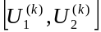 of human behavior shaped factor targets xi(i=1,2…,p),to form the factor to the human behavior the target xi (i=1,2…,p), can get a target’s fall-shadow function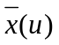.
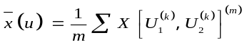 (1)
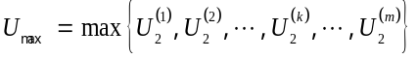 (2)
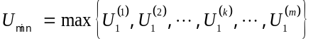 (3)
So the evaluation value of target xi is:
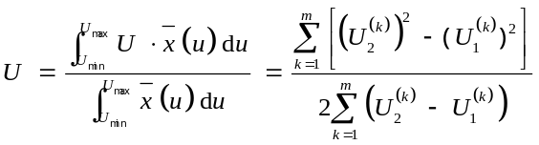 (4)
3.2 The Principal Component Analysis’s Principle and Calculation ^{[7]}
According to the principal component analysis principle, the principal component analysis basic algorithm and step is as follow:
(1) If analysis a study object, need to have p 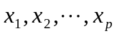 targets, this object has N group of sample data, can arrange the sample data as the following matrix:
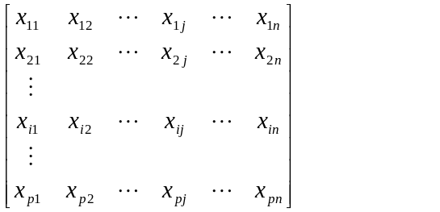 (5)
Define it as
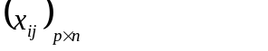 (6)
x_{ij} is i target’s value in j sample. According to above data calculate all covariance then list the covariance matrix.
The covariance formula is:
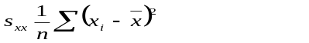 (7)
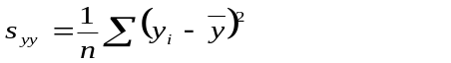 (8)
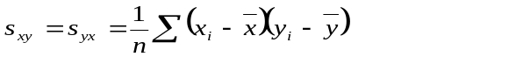 (9)
So, covariance matrix is:
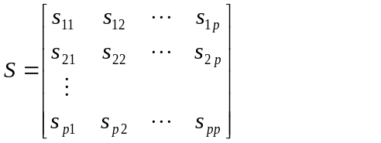 (10)
Carries on standardized processing for above covariance matrix, obtains correlation coefficient matrix R.
The standardized processing method is as follows:
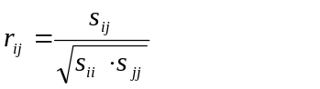 (11)
Correlation coefficient matrix R：
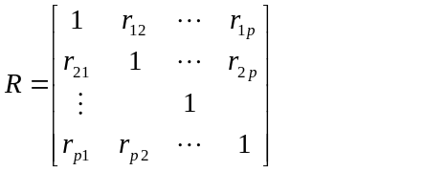 (12)
(4) Calculate p target value in matrix R,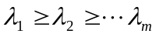, the characteristic equation:
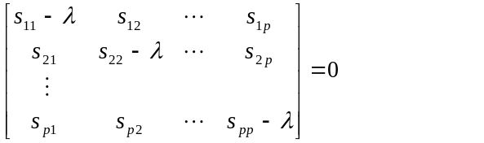 (13)
(5)Calculate the corresponding eigenvector
After calculate the eigenvalue, separately add those into the following equation to calculate its corresponding eigenvector.
The eigenvector equation is:
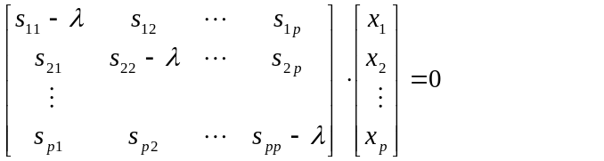 (14)
When p surpasses 4, it is very difficult to solve above equation with the elimination. In the practical application, must use the computer to solve the eigenvalue and the eigenvector.
Therefore, can obtain its eigenvector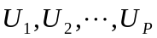, may prove is the standard orthogonal vectors. Can use the below equation express the h principal component:
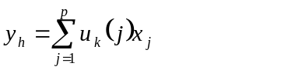 (15)
4 The Study of Human Behavior Shaped Factor in Building Fire Evacuation
4.1 Influencing Factor Determination
On the basis of analysis the factors which influence the human evacuation behavior ^{[8]}, combine with the some actual fire accidents and inquiry for evacuation behavior in fire evacuation, questionnaire survey, evacuation simulation and analysis the results of experiment simulation. Determine shaped factors which influence the human behavior in building fire: building structure (x₁),alarm device(x₂), fire, smoke or other noxious gas intensity(x₃), age(x₄), sex(x₅), walk speed(x₆), deformity(x₇), alcohol and drug influence(x₈), lying in sleeping or not(x₉), person number and person density in building(x₁₀), personal experience(x₁₁), emergency evacuation pre-arranged plan, education and train(x₁₂), influence of familiarity degree(x₁₃) and position(x₁₄).
4.2 Basic Case Data and Processing
After determination the above factors, the basic cases is important for using the principal components to determine the primary factor which influences the human behavior in building fire evacuation. Moreover in order to guarantee the authenticity of results, the cases should be as many as possible, also are representative. The expert evaluation is base on cases. In order to experts objectively, fairly and accurately evaluate the factors, so select the comprehensive case which is representative for all fire evacuation process. Because our country lack fire evacuation case data, therefore the selection cases main origin from foreign countries ^{[9-10]}, also choose the part result analysis. The case includes investigation and statistic after the fire and result of evacuation experiments. Expert evaluation should combine these cases and the influence factor set-value questionnaire, mark method and questionnaire accord to set-value statistics. According to customer’s questionnaire, take 10 cases, can get evacuation time as shown in table 1 after disposal.

4.3 The Human Behavior Shaped Principal Component Calculation and Analysis
On the Table 1foundation, use the principal components analysis obtains the correlation matrix’s latent root λ1, λ2,…λ14. Because its first 4 latent root accumulation contribution ratio has reached to 92.17%, therefore choose the first 4 latent roots as its principal component component, its result is shown in Table 2.
Applying the eigenvalue calculate the quantitative orthogonal rotation matrix of human behavior shaped primary factor. As shown in Table 3.

Table 1 The human behavior shaped factor set-value statistic value in building fire
Cases | Factors
Cases | x₁ | x₂ | x₃ | x₄ | x₅ | x₆ | x₇ | x₈ | x₉ | x₁₀ | x₁₁ | x₁₂ | x₁₃ | x₁₄
1 | 8.5 | 6.3 | 8.5 | 6.5 | 4.0 | 3.3 | 6.0 | 7.2 | 7.1 | 8.6 | 7.1 | 9.1 | 5.3 | 9.2
2 | 8.6 | 8.1 | 7.2 | 7.2 | 7.7 | 4.1 | 6.8 | 6.3 | 6.6 | 8.4 | 8.2 | 7.2 | 8.6 | 7.4
3 | 7.5 | 7.9 | 7.2 | 6.8 | 7.3 | 5.3 | 6.3 | 5.4 | 6.3 | 7.9 | 7.8 | 7.8 | 8.7 | 6.7
4 | 7.7 | 7.0 | 8.5 | 7.5 | 6.4 | 5.9 | 6.8 | 4.2 | 6.6 | 7.6 | 7.8 | 8.3 | 4.9 | 6.8
5 | 7.2 | 6.2 | 8.3 | 5.7 | 7.2 | 6.8 | 9.2 | 4.1 | 7.2 | 8.2 | 8.5 | 7.2 | 6.8 | 8.5
6 | 8.5 | 6.8 | 7.5 | 6.0 | 7.1 | 6.2 | 5.9 | 3.9 | 3.2 | 9.2 | 7.2 | 7.9 | 6.2 | 8.6
7 | 7.6 | 6.1 | 8.0 | 4.1 | 3.5 | 2.6 | 6.3 | 5.2 | 4.8 | 8.6 | 8.4 | 7.1 | 7.5 | 7.9
8 | 8.3 | 5.2 | 8.1 | 4.5 | 4.9 | 4.3 | 7.6 | 7.5 | 5.6 | 7.3 | 7.5 | 8.6 | 3.8 | 7.3
9 | 7.6 | 7.3 | 8.9 | 7.8 | 7.1 | 5.6 | 8.5 | 6.7 | 6.7 | 7.9 | 9.8 | 7.6 | 9.6 | 7.8
10 | 9.1 | 7.1 | 7.2 | 6.2 | 5.7 | 5.7 | 6.0 | 5.6 | 6.8 | 8.7 | 8.3 | 9.3 | 7.6 | 8.5

Table 2 Principal component components eigenvalue and contribution ratio
The principal component components serial number | Eigenvalue | Contribution ratio /% | Accumulative contribution ratio /%
1 | 18.41 | 74.92 | 74.92
2 | 2.01 | 8.2 | 83.12
3 | 1.46 | 5.94 | 89.06
4 | 0.76 | 3.11 | 92.17

Table 3 Variance maximum orthogonal rotation matrix
 | y₁ | y₂ | y₃ | y₄
building structure(x₁) | 0.7856 | 0.6541 | 0.1721 | -0.1789
alarm device(x₂) | 0.2561 | 0.7563 | 0.2587 | 0.8352
fire, smoke or other noxious gas intensity(x₃) | 0.6967 | 0.7458 | -0.1244 | 0.0056
age(x₄) | -0.1214 | 0.2426 | 0.5698 | -0.1657
sex(x₅) | 0.1145 | -0.3458 | 0.5356 | 0.2897
walk speed(x₆) | 0.7358 | -0.0561 | 0.6563 | 0.2571
deformity(x₇) | -0.1532 | 0.3214 | 0.5841 | 0.7654
alcohol and drug influence(x₈) | 0.2356 | 0.1612 | 0.7557 | -0.0017
lying in sleeping or not(x₉) | -0.1348 | 0.8535 | 0.0654 | 0.2521
person number and person density in building(x₁₀) | 0.5451 | 0.1746 | 0.1513 | -0.1475
personal experience(x₁₁) | 0.7941 | 0.2237 | 0.0864 | -0.0097
emergency evacuation pre-arranged plan, education and train(x₁₂) | 0.9648 | 0.0456 | -0.0145 | 0.6473
influence of familiarity degree(x₁₃) | 0.2265 | -0.2584 | 0.8247 | 0.2543
position(x₁₄) | 0.5582 | -0.1257 | 0.0541 | -0.2871

According to the table 3 variance maximum orthogonal rotation matrix, can get the relation of 4 human behavior shaped primary factors and 14 basic factors. The size of coefficient expresses the relation between primary factors and each basic factor. From the 2nd row , can know the 1st primary factor y₁ influenced by building structure(x₁), fire, smoke or other noxious gas intensity(x₃), walk speed(x₆), person number and person density in building(x₁₀), personal experience(x₁₁), emergency evacuation pre-arranged plan, education and train(x₁₂), position(x₁₄).The 2nd primary factor y₂ influenced by building structure(x₁), fire, smoke or other noxious gas intensity(x₃), lying in sleeping or not(x₉).The 3rd primary factor y₃ influenced by age(x₄), sex(x₅), walk speed(x₆), deformity(x₇), alcohol and drug influence(x₈), lying in sleeping or not(x₉), person number and influence of familiarity degree(x₁₃).The 4th primary factor y₄ influenced by alarm device(x₂), deformity(x₇), emergency evacuation pre-arranged plan, education and train(x₁₂).Can obtain the below equations
(16)
(17)
(18)
(19)
We can make the 1st principal component define as the basic principal component of human behavior in building fire evacuation according to the principal component analysis principle and physics significance of primary basic factor included by each principal component. It holds 74.92% proportions in human evacuation behavior shaping, therefore, it plays an important role for the human behavior shaping in building fire evacuation. We should mostly study the influence rule when study and analyze the human behavior in building fire evacuation, also analyze the reliability of human behavior in building fire according to those factors. Because the primary factor in the 2nd primary factor has relation with fire evacuation environment, so define it as environment factor in building fire evacuation. The primary factor in the 3rd primary factor has relation with individual characteristic in building fire evacuation, so define it as personnel characteristic factor in building fire evacuation. The primary factor in the 4th primary factor has relation with management in building fire evacuation, so define it as management factor in building fire evacuation.
Based on above classification and the analysis, in order to reduce the casualty in building fire, should mostly consider the basic factors such as building structure, smoke or other noxious gas intensity, walk speed, person number and person density in building, personal experience, emergency evacuation pre-arranged plan, education and train, and position and so on, which play an important role in human behavior shaping in building fire when make building fire protection design, evacuation pre-arranged plan and education and training. Improves these factors condition, makes it advantage for people to make the correct decision.
5 Conclusions
The human behavior in building fire evacuation is complex questions which influenced by the various factors. It is not realistic to consider human behavior mathematical expression including various factors because of human behavior’s uncertainty. The paper applies the set-value statistics and principal component to analyze the factor which influences the human behavior in building fire evacuation then conclude its primary factor. It can reduce person's fault in building fire evacuation, provide the foundation for enhance person's reliability, also provide the technical support for building performance-based and evacuation pre-arranged plan.

Acknowledgements
We would like to acknowledge the financial support of this work by HNEDU (No. 05B015) and HNSC (No. 05JJ40072).

References
- Xianshan Science Conference (The 135th symposium), Cities and industry safety engineering in the 21th century.
- Chen Quan, Chen Baozhi. Human behavior characters in fire evacuation.Safety, 1999, (1):39-42(in Chinese)
- Li Chunnian. Human behavior in fire. Shanxi: Shanxi Science and Technology Press, 1989(in Chinese)
- Wang Xu, Gao Yongting. Probing the countermeasures of safety evacuation for high rise building, China Safety Science Journal, 1996, 6(3):6-10(in Chinese)
- Wang Peizhuang. Fuzzy set and random set fall-shadow, Beijing: Beijing Normal University Press, 1985(in Chinese)
- Wang Wuhong, Cao Qi. Person fault and reliability analysis. Chengdu: Southwest Jiaotong University Press, 1996(in Chinese)
- Li Jinghua, Guo Yaohuang. Principal component evaluation-a multivariate evaluate method expanded from principal component analysis. Journal of Industrial Engineering/Engineering Management, 2002, (1):39-44(in Chinese)
- Xiao Guoqing. Human behavior theory and control study in building fire evacuation. Shenyang: Northeastern University, 2003, 24-31(in Chinese)
- J.L.Pauls, Movement of People, Handbook of fire protection engineering. SPPE, Massachusetts, 1989
- Jeremy Gardner, BSC, MCIBSE,MIFS, Building design and human behavior in fires. Fire Engineering Journal, 1996, (3):18-20

